**IOT BASED SMART AGRICULTURAL AND ALERTING SYSTEM**

**Abstract**

IoT based smart agricultural and alerting system is designed to help the Agriculture officers and farmers for improving the productivity. The system consists of 2 sections, one is a hardware module to perform institute diagnosis, such as soil test, humidity, temperature and PH. The hardware module can install in the field and works with solar power and internal battery. The system includes an internet module to upload the collected data in real time to the cloud. The second section is Machine learning based prediction tool. This tool make a prediction between the received data from hardware unit and historical data in that field (Collected from Agricultural officers). The prediction is loaded to the mobile app (Farmer mobile) and Agriculture office website. The same data can send to farmer mobile as SMS. During critical situations such as fire or high temperature alert, the system makes a voice call automatically in their regional language to farmer's phone for alerting the critical information.

**Working Principle**

The proposed system consists of 2 units. The block diagram is shown in Figure1.

1. Hardware Module

It provides a service to store the environmental and soil information collected from sensors using network installed in the planted area. The sensors are interfaced to a microcontroller,which sent the data to software unit. There is a mini solar-panel along with battery backup to give power to the micro-controller. NodeMCU used as microcontroller and Sensors are DHT11,DS18B20,NPK sensor and PH sensor.

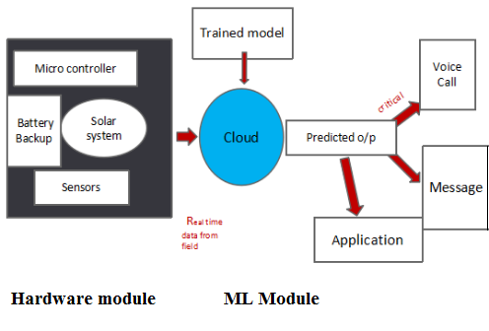

Figure 1: Block Diagram of Proposed Work

2.ML Module

Real time data from the field is sent to the thingspeak(cloud) using wifi provided in the hardware unit.That data is compared with the 97% accurate pretrained model. The model is trained by using machine learning technique. We trained the model by 67% data and testing by using 33% data.The machine learning algorithm used is Support Vector Machine (SVM). The overall block diagram of ML module is given in Figure 2.

The predicted output from the trained model is in cloud then it connected to ifttt, from IFTTT a voice call is received by farmer in regional language when the field parameters exceeding threshold value.At that time the agricultural officer get a notification message. Also we developed an application named ‘ILA’ for helping farmers and officers to early detect pest attack, disease prediction.

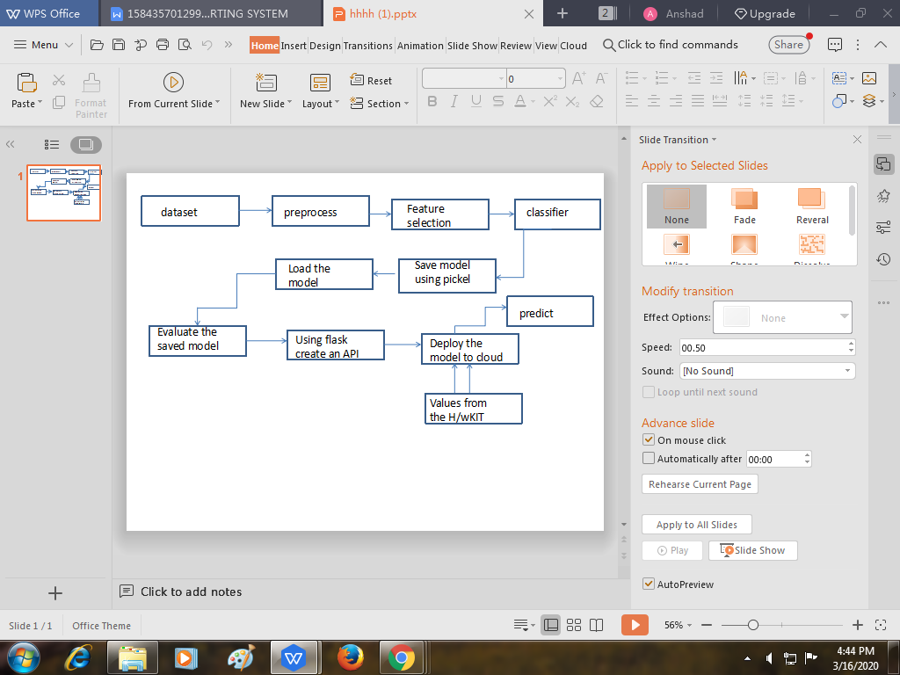

Figure 2: Block Diagram of ML module